3. Changes in the Operating Cycle [LO1] indicate the effect that the following will have on the operating cycle. Use the letter I to indicate an increase, the letter D for a decrease, and the letter N for no change:

a. Average receivables goes up.
b. Credit repayment times for customers are increased.
c. Inventory turnover goes from 3 times to 6 times.
d. Payables turnover goes from 6 times to 11 times.
e. Receivables turnover goes from 7 times to 9 times.
f. Payments to suppliers are accelerated.

11. Calculating the Cash Budget [LO3] Here are some important figures from the budget of Nashville Nougats, Inc., for the second quarter of 2015:

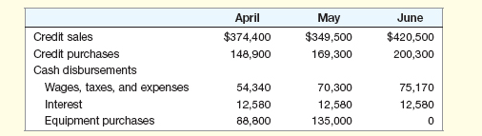

The company predicts that 5 percent of its credit sales will never be collected, 35 percent of its sales will be collected in the month of the sale, and the remaining 60 percent will be collected in the following month. Credit purchases will be paid in the month following the purchase. In March 2015, credit sales were $235,000 and credit purchases were $161,300. Using this information, complete the following cash budget:

8. Size of Accounts Receivable [LO1] The Arizona Bay Corporation sells on credit terms of net
30. Its accounts are, on average, four days past due. If annual credit sales are $9.75 million, what is the company's balance sheet amount in accounts receivable?

14. Credit Policy Evaluation [LO2] The Snedecker Corporation is considering a change in its cash-only policy. The new terms would be net one period. Based on the following information, determine if the company should proceed or not. The required return is 2.5 percent per period.

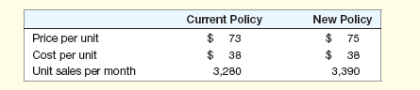

4. Using Spot and Forward Exchange Rates [LO1]

Suppose the spot exchange rate for the Canadian dollar is Can$1.09 and the six-month forward rate is Can$1.11.
a. Which is worth more, a U.S. dollar or a Canadian dollar?
b. Assuming absolute PPP holds, what is the cost in the United States of an Elkhead beer if the price in Canada is Can$2.50? Why might the beer actually sell at a different price in the United States?
c. Is the U.S. dollar selling at a premium or a discount relative to the Canadian dollar?
d. Which currency is expected to appreciate in value?
e. Which country do you think has higher interest rates--the United States or Canada? Explain.

Interest Rates and Arbitrage [LO2] the treasurer of a major U.S. firm has $30 million to invest for three months. The interest rate in the United States is .31 percent per month. The interest rate in Great Britain is .34 percent per month. The spot exchange rate is £.573, and the three-month forward rate is £.575. Ignoring transaction costs, in which country would the treasurer want to invest the company’s funds? Why?

1. Calculating Synergy [LO3] Pearl, Inc. has offered $357 million cash for all of the common stock in Jam Corporation. Based on recent market information, Jam is worth $319 million as an independent operation. If the merger makes economic sense for Pearl, what is the minimum estimated value of the synergistic benefits from the merger?

2. Balance Sheets for Mergers [LO2] consider the following premerger information about Firm X and Firm Y:
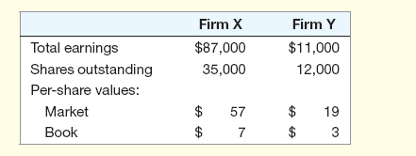
Assume that Firm X acquires Firm Y by paying cash for all the shares outstanding at a merger premium of $6 per share. Assuming that neither firm has any debt before or after the merger, construct the post merger balance sheet for Firm X assuming the use of purchase accounting.

